1. Website section – Programmes (one Tab ) & Certifications (One Tab)
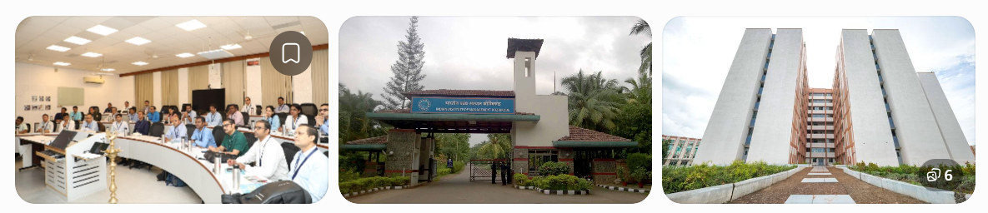
Programmes & Professional Certifications
Learn. Upskill. Lead.

Discover industry-focused executive education programmes, professional certifications and specialised learning experiences designed to meet the evolving needs of today's professionals and organisations.

Zenvogo aims to bring together academic expertise, industry knowledge and practical learning through collaborations with leading educational institutions, subject-matter experts and industry practitioners.

2. Academic institutions & programme development
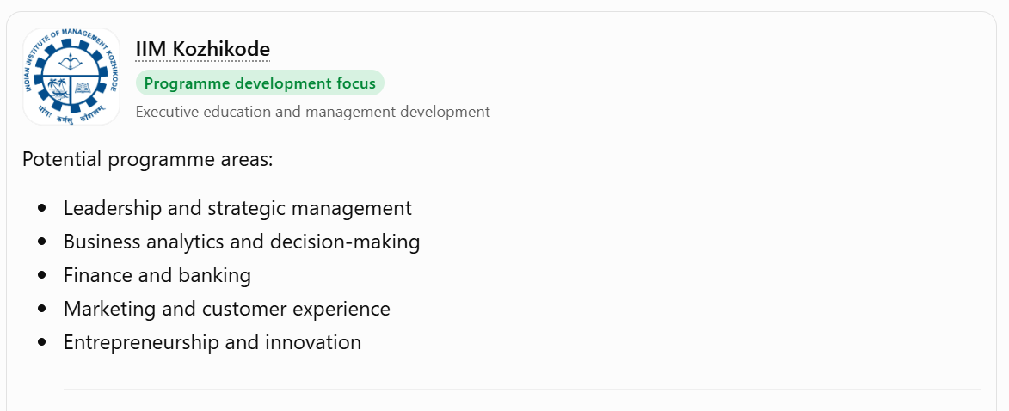

IIM Kozhikode
Programme development focus
Executive education and management development

Potential programme areas:
- Leadership and strategic management
- Business analytics and decision-making
- Finance and banking
- Marketing and customer experience
- Entrepreneurship and innovation

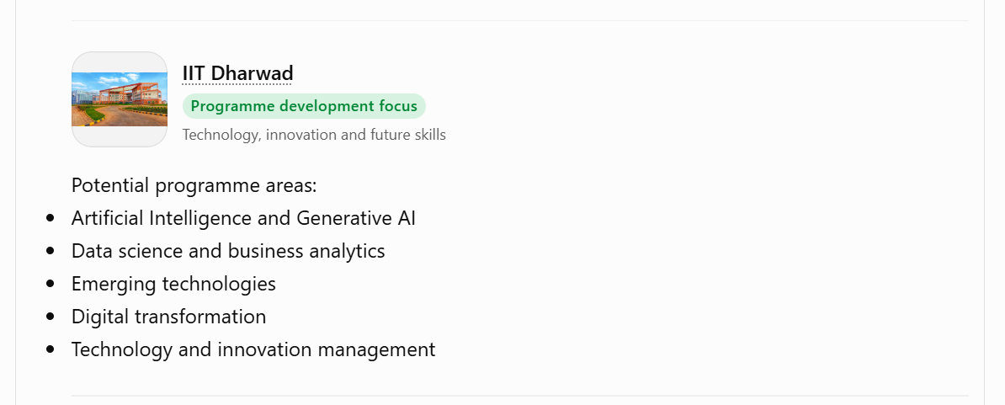
IIT Dharwad
Programme development focus
Technology, innovation and future skills

Potential programme areas:
- Artificial Intelligence and Generative AI
- Data science and business analytics
- Emerging technologies
- Digital transformation
- Technology and innovation management

Other Academic & Institutional Collaborations
We also intend to explore programme development opportunities with other reputed universities, business schools and technical institutions in India and internationally.

3. Upcoming programmes
Coming soon
New Programmes & Certifications
We are working towards developing a portfolio of specialised executive education programmes and professional certifications across management, technology, finance and emerging industry domains.

Programme announcements, academic collaborations and enrolment details will be released soon.
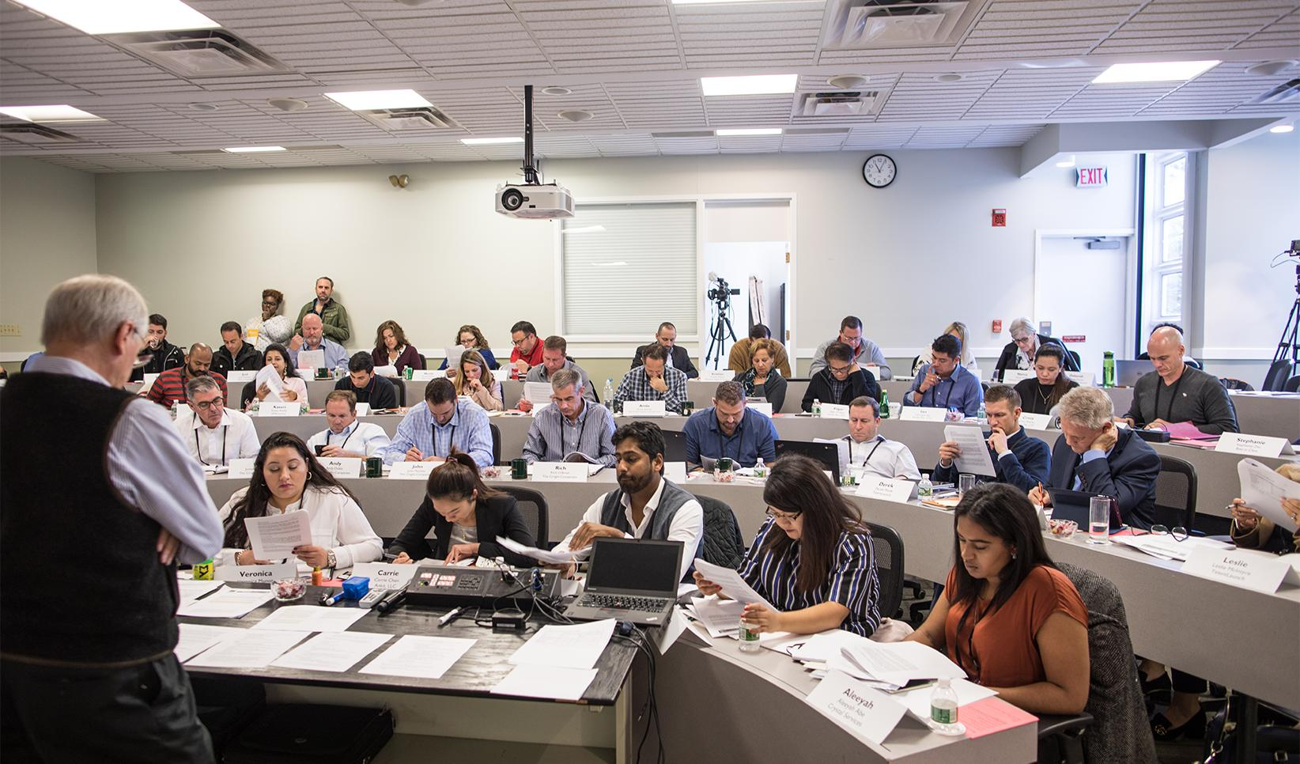
4. Suggested programme categories
Category Programme themes
Leadership & Management Strategic leadership, general management, decision-making
Technology & AI Generative AI, data analytics, digital transformation
Banking & Finance Banking operations, financial management, risk management
Marketing & Business Strategic marketing, sales leadership, customer experience
Industry & Operations Real estate, logistics, healthcare and supply chain
Entrepreneurship Start-up management, innovation and business growth

5. Short version for the homepage
Programmes & Professional Certifications
Build Skills. Advance Your Career. Stay Future-Ready.

Explore a growing portfolio of executive education programmes, professional certifications and specialised learning opportunities designed for working professionals, aspiring leaders and organisations.

Through programme development initiatives involving reputed academic institutions, including IIM Kozhikode and IIT Dharwad, Zenvogo aims to bring quality academic knowledge and industry-relevant skills closer to learners.

From leadership and management to Artificial Intelligence, business analytics, finance and emerging technologies, our upcoming programmes are designed around the needs of a changing professional landscape.

New programmes and institutional collaborations will be announced soon.

Stay connected for upcoming programme launches and enrolment announcements.

